## Problem 1 – Dream Vacation

Create a Web page (HTML5 + CSS3 + images + bootstrap or SASS/LESS) that looks and behaves like the screenshots below:

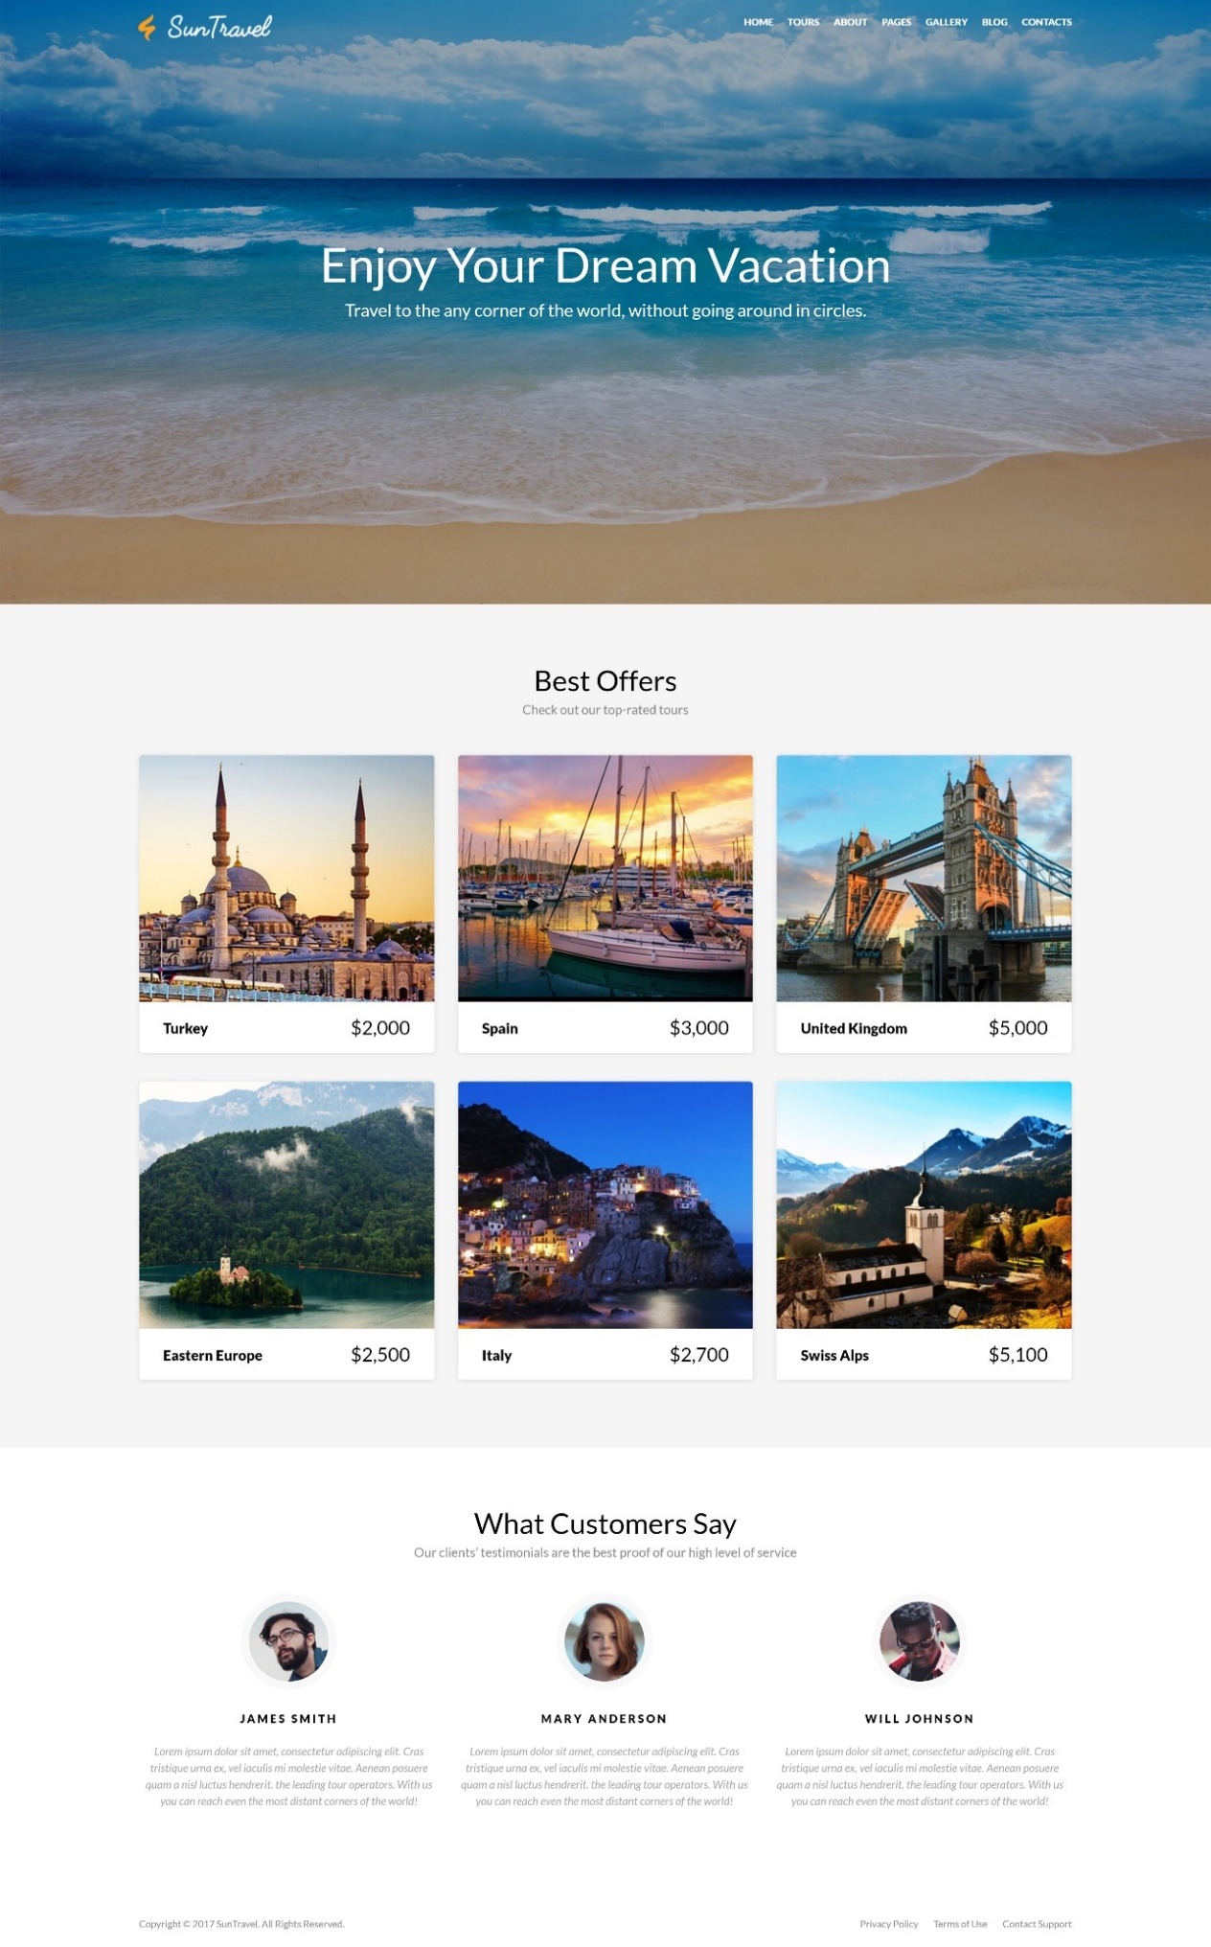

### Input

You are given the above screenshots + all required images + the texts on the site.

### Output

The output should be valid HTML5 + CSS3 + Bootstrap or SASS/LESS code + images that implement the above Web page.

### Constraints

* Use google font **Lato** - <https://fonts.googleapis.com/css?family=Lato:100,300,400,700,900>
* The site should open correctly in the latest version of Chrome
* Pixel-perfect implementation is not required.